**Enhancing Student Engagement and Presentation Skills** (Speakers: Ms. Pamela Truesdell, CEEMS Resource Person, UC; Dr. Kimya Moyo, Educational Consultant, Director of the Sakofa Educational Enrichment Program, and CEEMS Resource Person; and Ms. Barbara Doppes, CEEMS Teacher; July 9, 2015, 9:00 am–11:15 am)

This session was jointly lead by Ms. Pamela Truesdell and Dr. Kimya Moyo, both are members of Resource Team for the CEEMS Program at the UC. Ms. Truesdell biography has been presented on page I-71 for the PD session on CEEMS Poster Guidelines and Pointers, and so is not repeated here.

In addition to Ms. Pamela Truesdell and Dr. Kimya Moyo, Ms. Barbara Doppes also presented. She received a bachelor’s degree in biological science in 1990 from Northern Kentucky University. In 1999 she earned a Middle Grades Science endorsement from NKU. Currently, she is a seventh and eighth grade science teacher at Williamsburg Middle School. She is currently a teacher in the Cincinnati Engineering Enhanced Math and Science (CEEMS) program at the UC, funded by a grant from the National Science Foundation.

The presenters started the session off with a Brainstorming activity “Wind Turbines”. Few directions were given, groups were told to just “Go”. What the audience was unaware of was this was the hook. The presenters wanted to highlight real problems that exist in classrooms across the tristate area. Teachers often fail to create the climate and culture to support intentional learning. The audience was debriefed at the conclusion of the brainstorming session. Various teacher approaches were identified and shared out as shown in **Figure 1** below.

|  |  |
| --- | --- |
| **Figure 1: Teachers Were Asked to Brainstorm on Wind Turbines** | **Figure 2: Diagram is in the Shape of Gumby, as Teachers Have to be Very Flexible in Nature** |

For brainstorming to be effective, all stakeholders need to feel comfortable in sharing ideas. Creating the best possible classroom culture allows students to feel comfortable. The most efficient teachers are successful because they create a climate that is conducive to learning. Teachers must be like Gumby, smart and flexible each and every day in creating the best possible classroom environment. Presentations must be built into the culture of the classroom. It is the teacher’s job to establish the correct environment. The next part to the PD session focused on the mechanics of making group work successful in the classroom. All possible scenarios must be thought out before a teacher begins an activity. Important topics, such as, room lay out, ability groupings and assigning student roles, were discussed. Today’ education professional needs to consider multiple aspects with regard to structuring group work in the classroom. Flexibility is the key, as shown in **Figure 2**.

The last part of the PD was dedicated to giving teachers some tools to use in facilitating presentations in the classroom. The teacher participants worked through several activity types that will assist in creating the appropriate classroom culture. Presenters shared activities like; six slide power points, elevator pitches, and ted talks. The goal of these lessons is to keep students working in a focused and efficient manner which will produce a solid presentation. The teachers were reminded that all lessons need a rubric. Students should know what is expected of them. This is the only way that they will be able to create quality work in the end. The brainstorming activity from the beginning of the session was reintroduced, it is hard to meet unclear expectations.

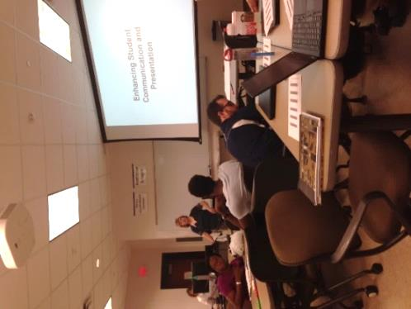

**Figure 3: Groups sharing “What Works”**

The session concluded with teachers sharing out what things are working in their classrooms. See figure 3, Ms. Pamela Truesdell facilitating a group share of different ways we use presentation in our classroom. This provided ways teachers help students in creating unique well thought out presentations on the regular bases. Teachers must guide students and create the type of climate that will foster excellent group presentations.